At AAVANTO Landscaping, we’re ready to help guide you to a stand out property, with a level of detail you can trust. We serve residential, commercial, and industrial customers across East Alabama and West Georgia, with a wide variety of landscaping needs, including:

[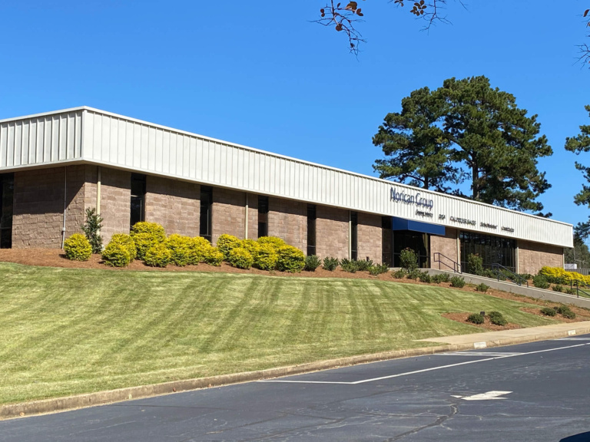](https://beaconlandscapingllc.com/assets/uploads/2020/11/services-lawn-maint.jpg)

Lawn Maintenance

We maintain lawns of diverse sizes, both commercially and residentially. We offer an array of lawn maintenance options for your lawn specifications.

Mowing the lawn can take up a whole afternoon—or just a moment. AAVANTO Landscaping will transform your property into a well-trimmed piece of paradise!

From LaGrange to Lake Martin, we’re ready to keep your turf in top shape, on your schedule.

Weed Control & Fertilization

Want to keep your lawn looking lush and weed-free? AAVANTO Landscaping offers a customizable weed control and fertilization program to keep your lawn looking its best.

Get in touch with us today to learn more about our plan options.

[**Get Started »**](https://beaconlandscapingllc.com/contact/)

[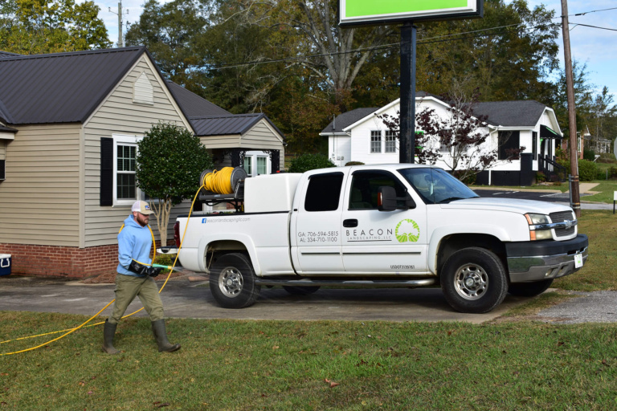](https://beaconlandscapingllc.com/assets/uploads/2020/11/about-office-spray.jpg)

[](https://beaconlandscapingllc.com/assets/uploads/2020/09/services-lcu.jpg)

Property Cleanup

Whether your grass has just grown too tall to handle, or you need an area cleared, we can handle it. We make Spring and Fall cleanups easy.

From removing weeds to cutting overgrown grass, we specialize in treating properties with TLC. You can look forward to spotless property after a visit from us!

Hedge Trimming

We can trim hedges of all sizes, shapes, and quantity. Neatly trimmed hedges will make all the difference to your property’s curb appeal.

Trimming your hedges isn’t as easy as pressing a button, but we’ll make it look that way! We’re experts in hedge thinning, hedge shaping, and hedge renewing too.

[**Let Us Handle It »**](https://beaconlandscapingllc.com/contact/)

[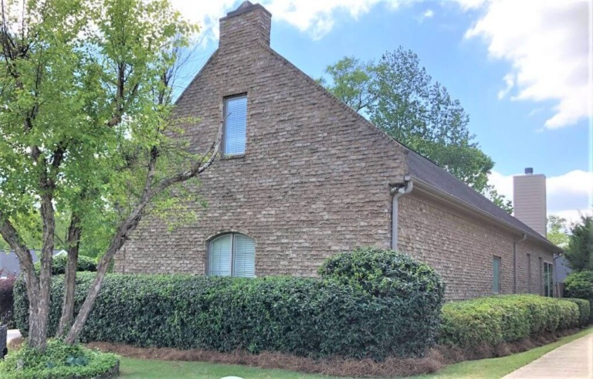](https://beaconlandscapingllc.com/assets/uploads/2020/09/services-ht.jpeg)

Hedge Trimming

We can trim hedges of all sizes, shapes, and quantity. Neatly trimmed hedges will make all the difference to your property’s curb appeal.

Trimming your hedges isn’t as easy as pressing a button, but we’ll make it look that way! We’re experts in hedge thinning, hedge shaping, and hedge renewing too.

[**Let Us Handle It »**](https://beaconlandscapingllc.com/contact/)

[](https://beaconlandscapingllc.com/assets/uploads/2020/09/services-ht.jpeg)

Irrigation Maintenance

An effective irrigation system is a critical part to the health and wellness of any landscape–and can even help you save money. Our trained professionals work to make sure your system is always functioning at its best, keeping your lawn, tree plantings, seasonal plantings and more healthy and looking great.

From irrigation system setup to checking on sprinkler heads and water lines, we’ll help make sure you’re set up for even watering across all areas of your property.

[**Get a Free Quote »**](https://beaconlandscapingllc.com/contact/)

[](https://beaconlandscapingllc.com/assets/uploads/2020/09/services-irrigation.jpg)

[](https://beaconlandscapingllc.com/assets/uploads/2020/11/services-installation.jpg)

Landscape Installation

Whether your property needs a little color, or a new look all together, we can guide you in the right direction. We can make your property stand out.

Your property deserves to look its best—and it will! Planting trees and shrubs, preparing plant beds, readying the dirt, doing rock work and creating walkways—we’ve got them covered. Simply tell us how you want your property to look and we’ll make it a reality.

[**Get In Touch »**](https://beaconlandscapingllc.com/contact/)

French Drains

French drains work by keeping water away from your home and other vulnerable areas like driveways, walkways and beyond. By managing water at ground level, these drains help prevent erosion and water damage by rerouting the water elsewhere.

Need a French drain on your property? Our experts are more than happy to help.

[**Get In Touch »**](https://beaconlandscapingllc.com/contact/)

[](https://beaconlandscapingllc.com/assets/uploads/2020/09/services-frenchdrain.jpg)

has the idea. We simply help them achieve their landscaping goals, so their property will “stand out” among the rest.

TAG LINE :- WE FULLFILL YOUR DREAM GREEN GARDEN WORLD

OUR WORKS :-